Directions for Logging into Microsoft Teams

1. Go to [www.rcboe.org](http://www.rcboe.org) , select students.



1. Under students select LaunchPad.

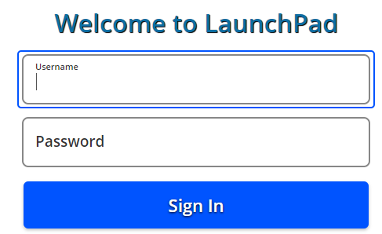

1. Once logged in select the Office 365 icon.

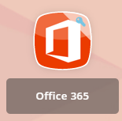

1. Select the purple Teams icon from the options on the left.

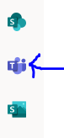

1. Once you’re in Teams, select the calendar.



1. Under the appropriate day, click Join

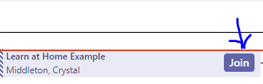

1. When you get to this screen, turn the camera and microphone on, click join now.

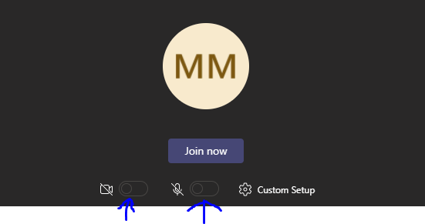

1. Enjoy the virtual learning experience with your teacher.